Command for all restaurants name and cuisine with at least 1 dish with score more than 50:

db.restaurant.find( { "grades.score": {$gt: 50} }, {_id:0, name:1, cuisine:1} ).pretty()

(“pretty()” will make the entry more human readable)

screenshot:

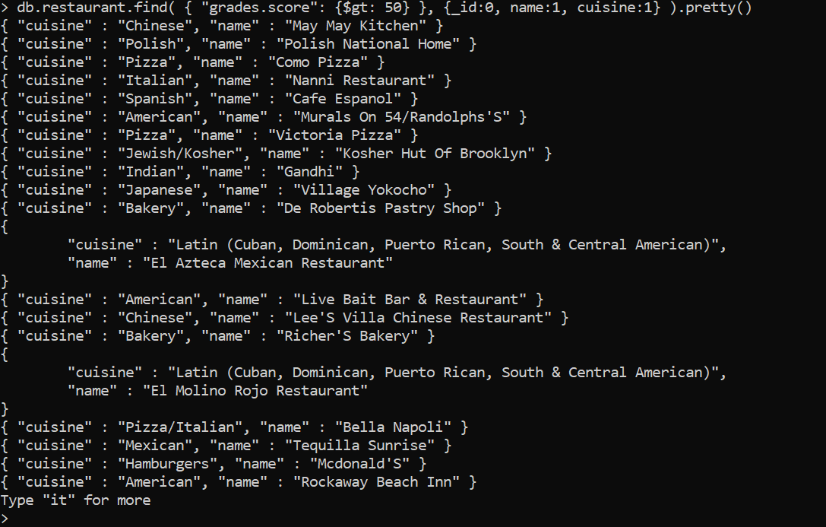

Command for that one’s count only:

db.restaurant.find( { "grades.score": {$gt: 50} }, {_id:0, name:1, cuisine:1} ).pretty().count()

Screenshot:

